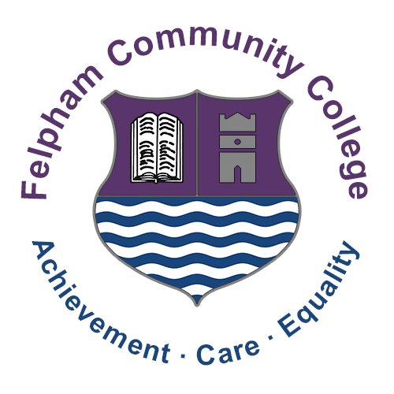
Felpham Community College
PRESS RELEASE

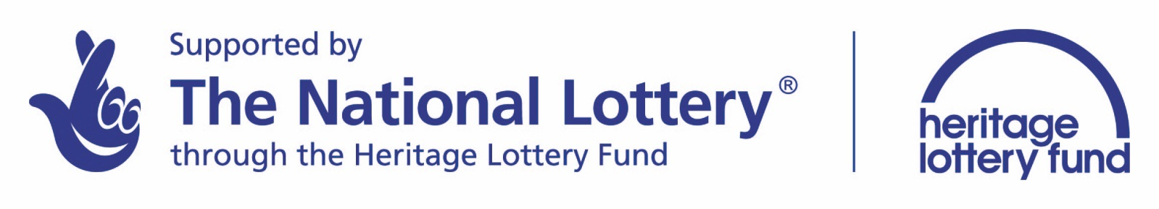

Heritage Lottery Fund – The Blake Project

We are delighted to announce that Felpham Community College (supported by Big Blake and Millstream Productions) have been granted a £34,000 investment from the Heritage Lottery Fund to develop a Heritage Trail enabling people to walk in Blake’s footsteps.

Feet are very important to William Blake whose question ‘And did these feet?’ starts the hymn known as ‘Jerusalem’, which was written by Blake when he lived in Felpham village.

Products to be created are physical trail signs, web-pages, trail leaflets and film-shorts. Students will be developing skills in heritage research, film-making, web-page creation and sign design. The University of Chichester will be working with the students running history workshops and there will be a number of field trips linked to the project.

All Key stage 4 students at Felpham have been invited to apply to be part of the Trail and a student management committee is also currently being set up to drive the project forward.

Mark Anstiss, Headteacher commented:
“This is an exciting project for our school and we hope as many KS4 students as possible choose to get involved. We want the work produced to be as aspirational as possible, which the whole community can be proud of.”

About the Heritage Lottery Fund
Using money raised through the National Lottery, the Heritage Lottery Fund (HLF) aims to make a lasting difference for heritage, people and communities across the UK and help build a resilient heritage economy. From museums, parks and historic places to archaeology, natural environment and cultural traditions, we invest in every part of our diverse heritage. HLF has supported almost 35,000 projects with more than £5.3bn across the UK. www.hlf.org.uk.

May 2016





Felpham Way, Felpham, Bognor Regis
West Sussex PO22 8EL
College Tel: 01243 826511
College Fax: 01243 841021
Email: fcc@felpham.org.uk
Website: www.felpham.org.com

